1. Write a Java program to convert a given integer (in seconds) to hours, minutes and seconds.

Input seconds: 25300 Expected

Ans:-

import java.util.Scanner;

class HMS{

public static void main(String args[]){

Scanner rk=new Scanner(System.in);

System.out.println("Enter the second: ");

int second=rk.nextInt(); //25300

int raj=second%60;

int hours=second/60;

int minutes= hours%60;

hours=hours/60;

System.out.print("Time:"+hours+":"+minutes+":"+raj);

}

}

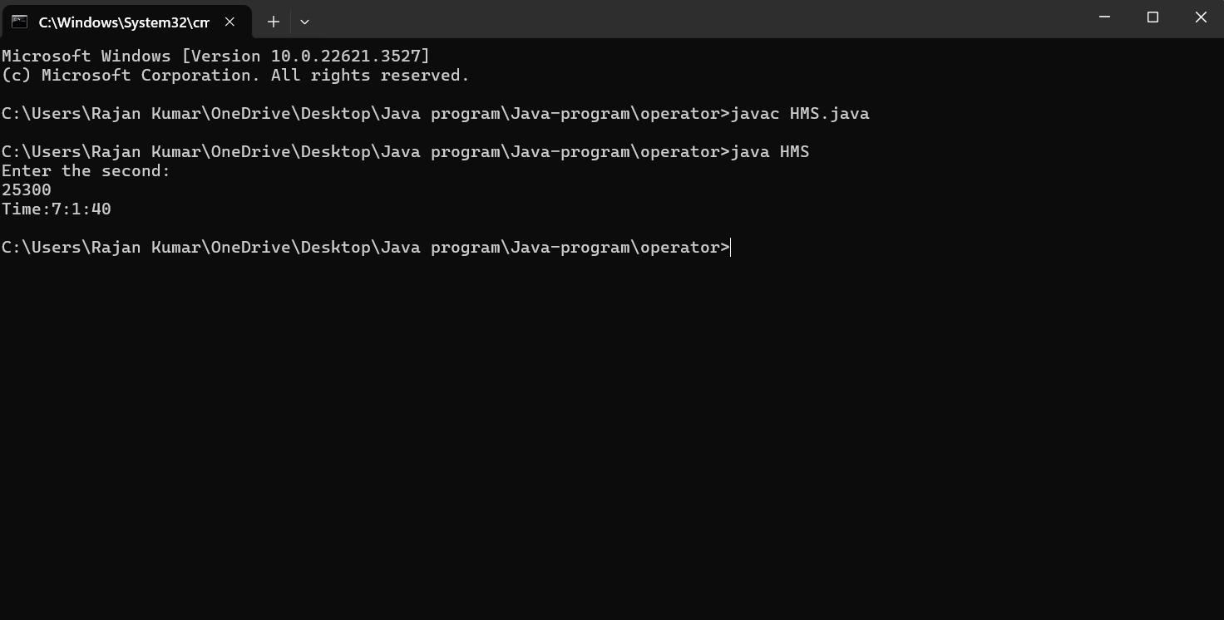

2. Write a Java program to convert a given integer (in days) to years, months and days,assumes

that all months have 30 days and all years have 365 days.

Test Data : Input no. of days: 2535

import java.util.Scanner;

class Years{

public static void main(String args[]){

Scanner rk=new Scanner(System.in);

System.out.print("Enter the Days:");

int raj=rk.nextInt();

int years=raj/365;

raj=raj%365;

System.out.println(years+" Years:");

int months=raj/30;

raj=raj%30;

System.out.println(months+" Months:");

int days=raj;

System.out.println(days+" Days:");

}

}

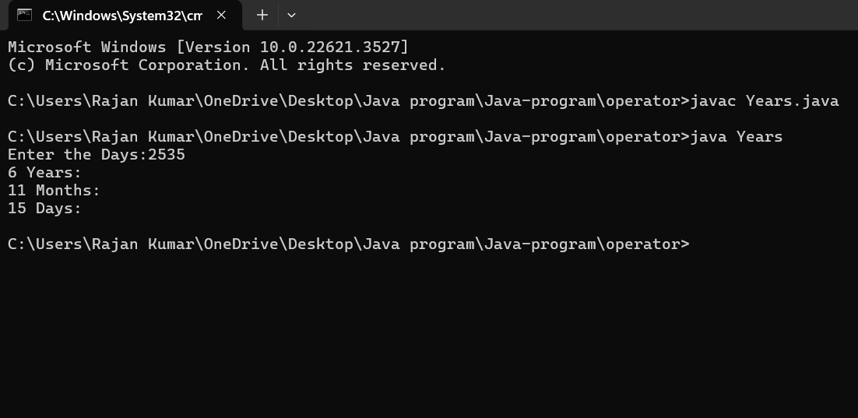

Q3. Write a Java program that read 5 numbers and print the average of all values.

Test Data :

First Number : 4

Second Number : 6

Third Number: 8

Fourth Number : 10

Fifth Number : 12

import java.util.Scanner;

class Avg{

public static void main(String args[]){

Scanner rk=new Scanner(System.in);

System.out.println("Enter the first number:");

int num1=rk.nextInt();

System.out.println("Enter the second number:");

int num2=rk.nextInt();

System.out.println("Enter the third number:");

int num3=rk.nextInt();

System.out.println("Enter the fourth number:");

int num4=rk.nextInt();

System.out.println("Enter the fifth number:");

int num5=rk.nextInt();

int a;

a=num1+num2+num3+num4+num5;

int b;

b=a/5;

System.out.println("Average of that's number:"+b);

}

}

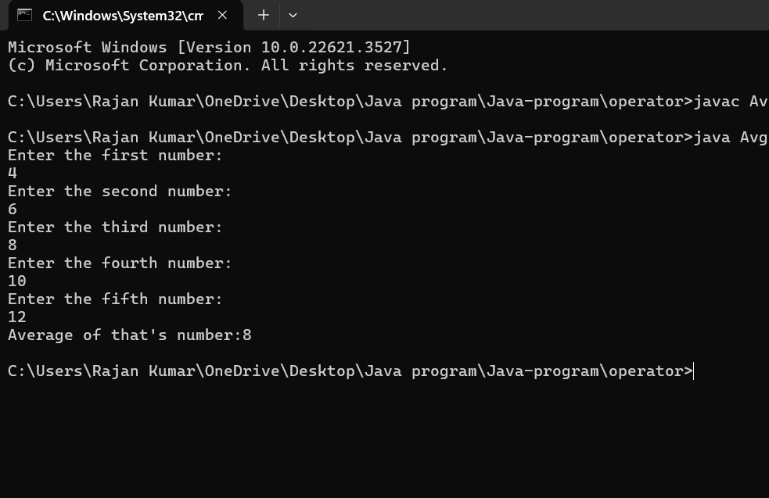

Q4. Write a Java program to integral quotient and remainder of a division

Input numerator : 2500

Input denominator : 235

import java.util.Scanner;

class Numenator{

public static void main(String args[]){

Scanner rk=new Scanner(System.in);

System.out.println("Enter the numerator:");

int a=rk.nextInt();

System.out.println("Enter the Demerator:");

int b=rk.nextInt();

int c,d;

c=a/b;

d=a%b;

System.out.println("Quotiant="+c);

System.out.println("Remaider="+d);

}

}

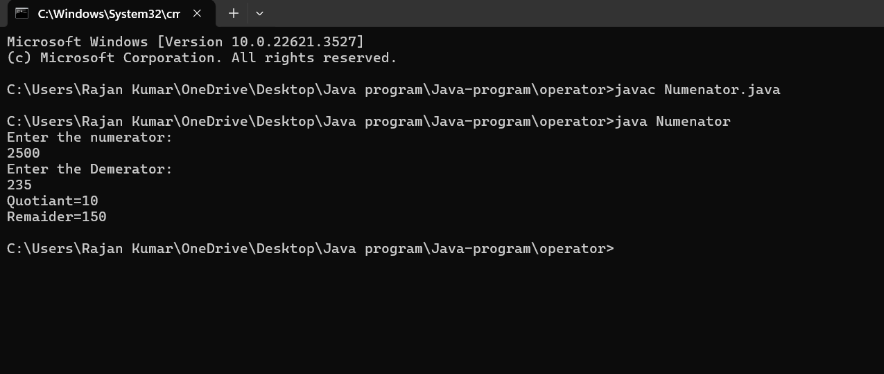

Q5. Write a java program that converts Centigrade to Fahrenheit.

Input a degree in Fahrenheit: 212

import java.util.Scanner;

class FarTocel{

public static void main(String args[]){

Scanner rk=new Scanner(System.in);

System.out.println("Enter the farenheit");

double f=rk.nextDouble();

double c;

c=(5\*(f-32))/9;

System.out.println(f+" degree farenheit is equal to " +c+" in celcius");

}

}

